William Colon

3-2 Milestone Two

Enhancement One: Software Design and Engineering

From one of my previous classes, specifically the CS-320 software development lifecycle, I chose artifacts that focused on an appointment system in java. I choice to convert this code to C++ based on two reasons.

I'm not a developer, so I'm lacking a wide range of coding experiences and found the best instructions to understand C++. First I had to enter my code directly into the program. After extensive research and teaching videos, I developed a feature that requires users to enter information step by step when running the program.

I created an e-portfolio to present this project and uploaded it to highlight my skills in C++ and object-oriented programming. In the future, I plan to improve my application by adding functions that store all my data in the database, but I haven't found a way to implement it yet.

I think I have successfully achieved the course objectives I set for myself. When I thought about the process of changing and improving artifacts, I found that achieving a broader perspective has contributed greatly to my learning. This experience has allowed me to see and understand things from a distant, clear perspective.

First the info was embedded in the code 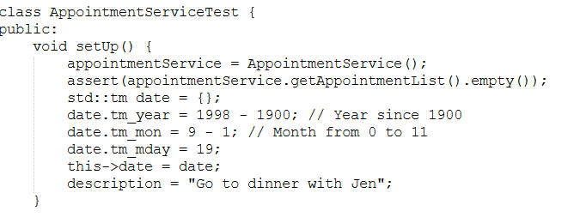

I added the function, so the program asks for the information

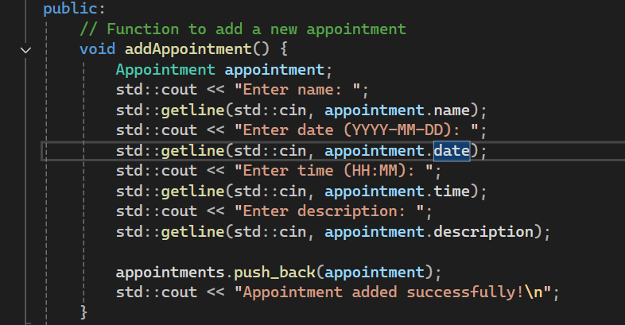

This function will display any previews appointment 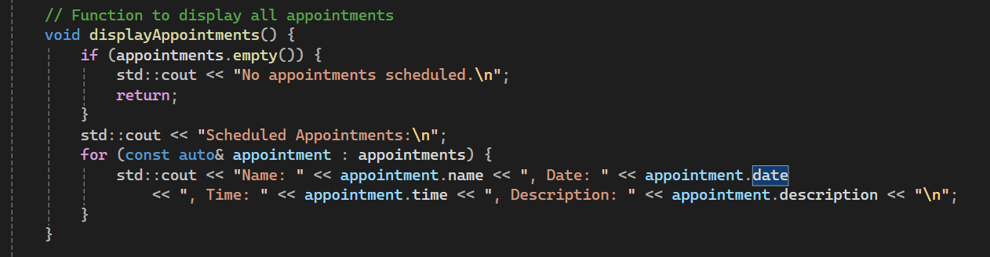

With this one you can delete all the previews appointments.

